IDE 2026 RAMS

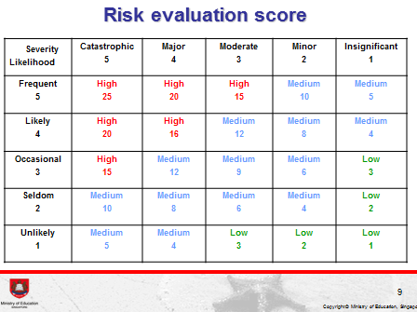
Risk Level Evaluation
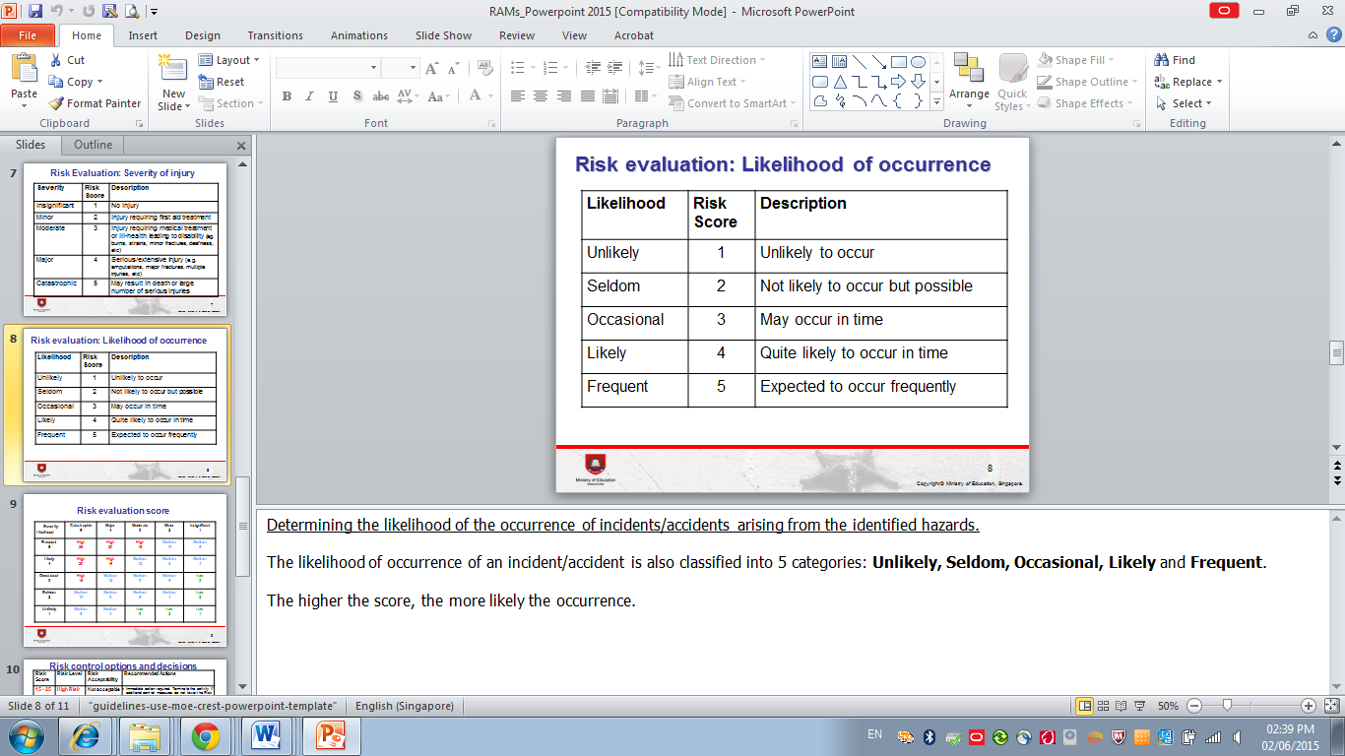
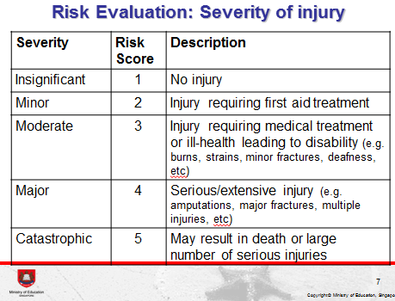

S/n | Hazards Identification |  |  | Risk Evaluation Score |  |  | Risk Control:  Strategies to reduce risk to an acceptable level | Implementation
S/n | Description of Activities/ Work Processes | Possible hazards | Potential incidents/ accidents | Severity (a) | Likelihood (b) | Risk level (a) x (b) |  | Action Officer, Designation  (Follow-up date) | Remarks
 | WHAT
1. | Equipment
1. | a) Foldable tables and plastic chairs will be used as booths/preparatory stations for participants. | Damaged tables/chairs | Cuts or falls due to loss of balance. | 2 | 2 | 4 | All tables and chairs are to be checked for defects prior to event day and before using them. | IDE organizing committee  Teacher in charge
1. | b) Materials used by participants  - IDE Maker  - Laptop  - Arduino/Micro:bits and electronic components  - IDE Robotics, IDE Sprint, Sumo  - LEGO SPIKE Prime/EV3/ NXT Robotics platform  - IDE Code Builder/Code Hacker  - Laptop | - IDE Maker  - Electricity  - IDE Robotics / Sprint / Sumo  - Sharp parts  - IDE Code Builder/Code Hacker  - Electricity | - IDE Maker  - Poor cable management of laptop charging stations  - Short Circuit  - IDE Robotics, IDE Sprint, IDE Sumo  - Poor handling of robot leading to injuries  - IDE Code Builder  - Poor cable management of laptop charging stations | 2 | 2 | 4 | - IDE Maker  - Wire management  - All circuits presented in the product are to be properly insulated.  - IDE Robotics, IDE Sprint, IDE Sumo  - Safety reminders to participants  - IDE Code Builder/Code Hacker  - Safety reminders to participants  - Wire management | IDE organizing committee  Teacher in charge
2. | Transport
2. | a) Transportation service is reliable (e.g. driver, vehicle). | Late arrival at the event venue  Late pick-up at the event venue | Unnecessary panic behavior | 2 | 1 | 2 | School/Teacher in charge of independent schools should ensure transportations are properly timed | School / Teacher in charge
3. | Food
3. | a) Food is provided by KG Catering | Late consumption of food | Diarrhea and vomiting due to food poisoning | 3 | 2 | 6 | Serving of food timed to ensure meal time comfortably falls within the 4-hour safe consumption duration. | IDE organizing committee  / Caterer
3. | b) Water coolers are also easily accessible within the competition grounds. | Non-potable water  Lack of water to drink | Diarrhea and vomiting due to food poisoning  Dehydration | 3 | 1 | 3 | Teacher in Charge will ensure students are well hydrated throughout the day with safe to consume water | Teacher in charge / Students
 | WHEN (TIMING)
4. | Programme
4. | - Duration of activity is appropriate (e.g. start/stop/rest time).  - Adequate lunch break of 1 hour is provided | Delayed lunch break | Fainting spells due to hunger or tiredness | 3 | 1 | 3 | Organizers will ensure that as much as possible, the timing for a lunch break is adhered to. | IDE organizing committee
4. | - Possible delay in activity | Late dismissal | Missing transport back to school or arriving back in school later than indicated on the consent form. | 1 | 2 | 2 | Organizers will ensure that as much as possible, no delays should occur.  Buffer time for traveling has been accounted for. | IDE organizing committee  Teacher in charge
 | WHO (PEOPLE)
5. | Teachers and Adult Supervisors
5. | a) Teacher(s)/adult supervisor(s) are competent to supervise activity and manage participants | Lack of manpower to account for all students | Missing students. | 1 | 1 | 1 | Teachers to ensure that the student-teacher ratio is met.  Organizers will ensure that clear location maps are printed and placed around the competition area.  Ushers will be deployed around the competition grounds. | Teacher in charge  IDE organizing committee
5. | b) Personnel is certified and competent to conduct the activity. | Improper handling of situations involving students | Injuries or aggravating of emotional situations involving students. | 1 | 2 | 2 | Organizers to ensure that all staffs involved are properly briefed on expected procedures and safety precautions prior to the commencement of the competition. | IDE organizing committee
5. | c) Certified First Aider or paramedic is on site.  - A nurse office is opened and accessible from within the competition venue. | Lack of First Aid assistance | Inability to locate Nurse Office or ask for help during emergencies. | 2 | 2 | 4 | Organizer to ensure that the on-site nurse office is opened during the entire duration of the competition.  Organizer to place location maps clearly showing the location of the nurse office around the competition venue. | IDE organizing committee
5. | d) Personnel is competent to co-ordinate/execute emergency evacuation plan (e.g. search and rescue). | Lack of understanding of evacuation | Injuries due to delayed evacuation | 5 | 2 | 10 | Organizers to ensure that all staffs involved are properly briefed on expected procedures and safety precautions prior to the commencement of the competition. | IDE organizing committee
5. | e) Others :
6. | Participants
6. | a) Participants are competent for activity (e.g. participate in pre-activity training). | Incompetence handling of equipment | Injuries due to mishandling of equipment | 2 | 2 | 4 | Teachers to ensure that selected students have been adequately trained prior to competition. | Teacher in charge
6. | b) Participants are aware of and adhere to the safety requirements of the activity. | Incompetence handling of equipment | Injuries due to mishandling of equipment | 2 | 2 | 4 | Organizers are to conduct a safety brief prior to the commencement of the competition.  Teachers reinforce the importance of safety with students. | IDE organizing committee  Teacher in charge
6. | c) Medical declaration and information of participants are documented and disseminated to relevant personnel. | Emergency medical situation related to a known medical history of participant. | Emergency medical attention required | 3 | 1 | 3 | Teachers to ensure that all crucial medical information of students are taken note of. | Teacher in charge
6. | e) Others :
 | WHERE
7. | Venue
7. | a) Fire safety and evacuation route is communicated to all participating and supporting members | Lack of understanding of evacuation | Injuries due to delayed evacuation | 5 | 2 | 10 | Organizers conduct a safety briefing prior to the commencement of the competition.  Teachers reinforce the importance of safety with students. | IDE organizing committee  Teacher in charge
7. | b) Area map is available for use during the activity. | Lack of understanding of evacuation | Injuries due to delayed evacuation | 5 | 2 | 10 | Organizers to conduct safety emphasizing the availability of such maps prior to the commencement of the competition.  Teachers reinforce the importance of safety with students. | IDE organizing committee  Teacher in charge
7. | c) Reconnaissance of the area is conducted. | Unforeseen obstruction along the designated route or along an evacuation route | Injuries due to delayed evacuation | 5 | 2 | 10 | Organizers to conduct reconnaissance a day before the competition | IDE organizing committee
7. | d) Others :
 | WEATHER
8. | Inclement Weather
8. | a) Weather forecast and warning (e.g. lightning, flash flood, hot or cold spell, haze). | Not possible. The activity venue is sheltered. | Nil
8. | b) Others :

